Research Article
Click and type the title of your paper, only capitalize first word
First Author ª , Second Author ^{b,}* , Third Author ^{a,b}

ARTICLE INFO |  | ABSTRACT
Article history:  Received 12 March 2020  Accepted 29 July 2023 |  | An abstract is required for every paper; it should succinctly summarize the reason for the work, the main findings, and the conclusions of the study. The abstract should be no longer than 300 words and line space should be 1. Abstract is not included artwork, tables, elaborate equations or references to other parts of the paper or to the reference listing at the end. The reason is that the Abstract should be understandable in itself to be suitable for storage in textual information retrieval systems. (Times New Roman, font 9)  This is an open access article under the CC BY-SA 4.0 license.  (https://creativecommons.org/licenses/by-sa/4.0/)
Keywords:
At least three keywords. Each keyword to start on a new line in alphabetical order.
(Times New Roman, font 8, upper case at the beginning of each keyword)

- Introduction
This document is a template for Microsoft Word. If you are reading a paper or PDF version of this document, please download the electronic file (.docx), from the http://dergipark.gov.tr/ijamec so you can use it to prepare your manuscript.
Introduction section should be included current studies and contribution of the study. All text will be prepared by Times News Roman and font 10. The full manuscript should be between 5–12 pages and line space should be 1,15.
ORCID link must be added on figure for all authors. If authors don’t have ORCID, they get by https://orcid.org/
- New Section (Times New Roman, Font 11, Bold)
  - Subsection (Times New Roman, 10, Italic, Bold)
The second part consisting of the paper body must be edited in double column format. Figures and tables should be located at top or bottom of either column.
Clear original figures should be used. Equations should be numbered consecutively throughout the paper and located at the right margin as in Equation (1) below. Figures and tables should be placed at the top or at the bottom of each column as in Figure 1 and Table 1. Large size figures or tables can be placed in one column as given Figure 2 at the top or at the bottom of each page.
Table 1. Ram position details of the motion segments (Times New Roman, 9)
Segment | Time(s) | Ram Position(m)
1 | 0 | 0.20
2 | 0.5 | 0.04
2 | 2.1 | 0
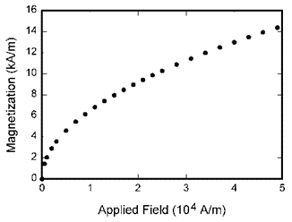
Figure 1. Motion Scenario (Times New Roman,9)
For instance, Lagrangian function states the difference between system kinetic energy and potential energy as in Equation (1) in which L, T and V refer to Lagrange function, kinetic energy and potential energy of system, respectively.

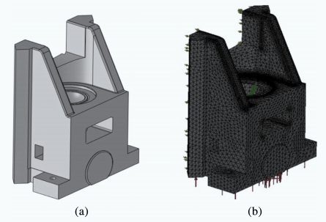
Figure 2. Part assembly a) design, b) design with mesh
  - Reference
The recommended format of References is IEEE citation style. References should be referred in text by numerals in square brackets in order etc [1], [2]. References (in font 8.5) should appear in a separate bibliography at the end of the paper. All journal articles must include volume, number, and pages. “IEEE” style can be used by EndNote or Mendeley. For web pages, please write date of the available data.
    - Tables
Data charts which are typically black and white, but sometimes include color.
    - Equations
Number equations consecutively with equation numbers in parentheses flush with the right margin, as in (1). First use the equation editor to create the equation. Then select the “Equation” markup style. Press the tab key and write the equation number in parentheses. To make your equations more compact, you may use the solidus ( / ), the exp function, or appropriate exponents. Use parentheses to avoid ambiguities in denominators. Punctuate equations when they are part of a sentence, as in
$$L=T-V$$ | (1)
$f\left(x\right)=a_{0}+\sum_{n=1}^{∞}{\left(a_{n}\cos{\frac{nπx}{L}}+b_{n}\sin{\frac{nπx}{L}}\right)}$ | (2)
- Conclusions
The review process will be conducted on the internet, with the two blind reviewers. At least one of the researchers must have completed the registration of the congress in order for the declarations to be taken into consideration. The outcome of the evaluation will be sent to all the declaration holders as a result letter.

Acknowledgment
This work supported supported by the Department of Engineering under Research Project (project no:XXXXX), Country Name.

References
- A. Author1 and B. Author2, Title of Book in italics. City: Publisher, Year. DOI: (insert DOI here if one exists for this reference) (Book in print)
- C. Author3, “Title of Chapter,” in Title of Book in italics, A. A. Editor1, Ed. City: Publisher, Year, pp. #-#. DOI: (insert DOI here if one exists for this reference) (Chapter in book)
- D. D. Author4, "Title of journal article," Title (or Abbreviated Title) of Journal in italics, vol. #-#, pp. #-#, Month Year. DOI: (insert DOI here if one exists for this reference) (Journal article)
- E. Author5 and F. Author6, "Title of conference paper," in Title of Conference in italics: Proceeding of the #th #, Conference abbreviation Year, City, Country, Month Day#-Day##, Year, B. Editor2, C. Editor3, Eds. Publisher, Year. pp. #-#. DOI: (insert DOI here if one exists for this reference) (Conference paper)
- STANDARD NAME Title of Standard in italics, STANDARD NAME Standard #, Year. DOI: (insert DOI here if one exists for this reference) (Standard)
- G. G. Author7, “Title of Thesis/ Dissertation,” Ph.D. dissertation, Department, University, City, Year. DOI: (insert DOI here if one exists for this reference) (Thesis/Dissertation)
- A. A. Owner1, “Tile of Patent,” Country. Patent #, Month Day, Year. DOI: (insert DOI here if one exists for this reference) (Patent)

